ECE 241L — Intro to EE Lab

Lab 5: Realizing a Constant Current Source

Objective
To build and simulate a transistor circuit that implements a constant current source.

Equipment
Computer with LTSpice; 1x 2N3906 PNP Transistor, 1x 2N3904 NPN Transistor, 4x 10k Ohm resistor, 1x 1k Ohm resistor, 1x 10nF capacitor; Function Generator, Oscilloscope, Power Supply.

Introduction
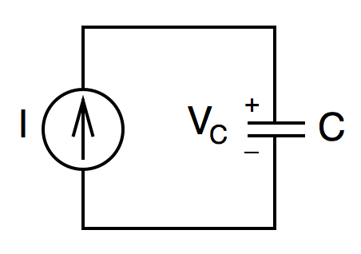
We use the schematic symbol for a constant current source because the abstraction simplifies circuit analysis. Take for example the simple circuit shown below.

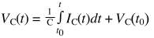
This circuit is often used to show the relationship between Capacitor voltage and current. Recall that that capacitor voltage and current are related by the following integral equation:

Notice that when dealing with a constant current source (and assuming zero initial voltage) the above equation simplifies to a linear function of time:

The circuit shown above makes a very unrealistic assumption, namely that the voltage across the capacitor can continue to ramp up indefinitely.

In this lab we will simulate and build a physical circuit that implements a constant current source that charges a capacitor. We will address the issue of an unbounded voltage ramp by adding additional circuitry that periodically discharges the capacitor.

Transistor Overview
In this lab we will use two transistors: in the constant current source portion we will use a PNP transistor, and in the discharge portion of the circuit we will use an NPN transistor. Below we provide the circuit symbols and their simplified functional models for both transistors.

Figure 1 — Schematic symbols for NPN and PNP transistors. These are BJTs (Bipolar Junction Transistors). They are 3-terminal devices: E (emitter), B (base), and C (collector). The arrow indicates the direction of current flow in the emitter.

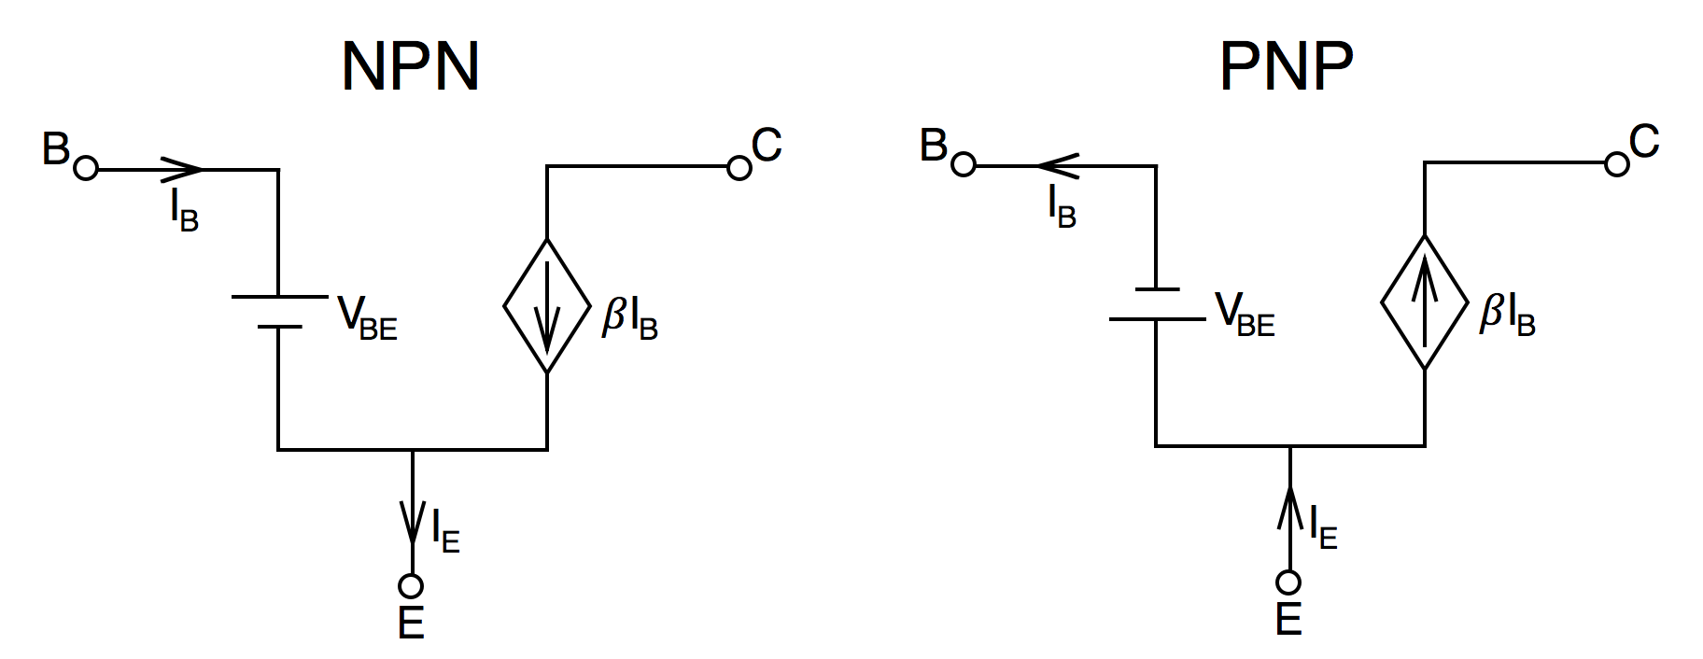
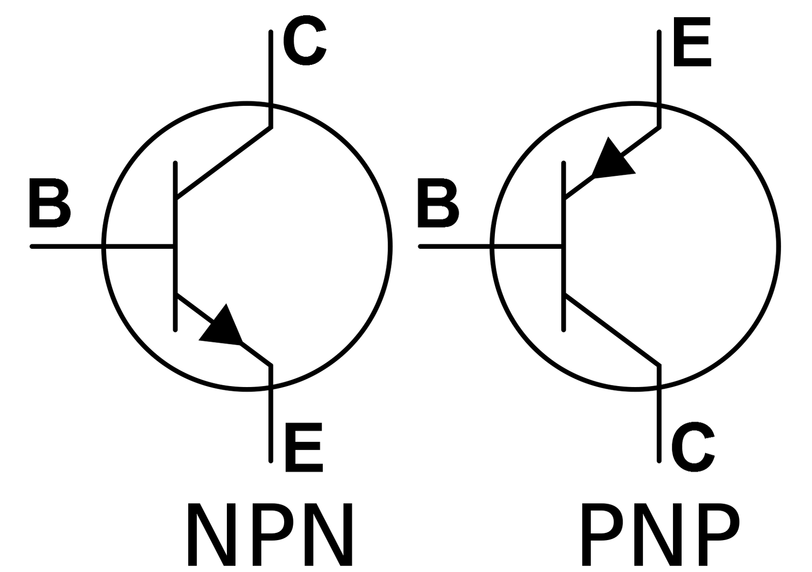
Figure 2 — Approximate DC models for NPN and PNP transistors. In the context of how we’ll be using them, both transistors can be modeled as current-dependent current sources. The symbol β represents the current gain, typically its value is 100 or more (alternatively h_{FE} is also used instead of the symbol β). The voltage source in each diagram models the constant voltage drop (typically about 0.7V) across the base-emitter of the BJT.

Figures 1 and 2 above show the schematic symbols and DC models respectively for both NPN and PNP transistors. In this lab we’ll be using two specific models: a 2N3904 (NPN) and a 2N3906 (PNP). Both models are available in LTSpice for simulation. By the way there’s nothing inherently special about the 2N3904 and 2N3906. Almost any other low power NPN and PNP transistors could be used.

Figure 3 depicts the physical pinout of our transistors. The original image along with detailed electrical characteristics can be found online in the transistors’ datasheets. Simply do a google search for the part number e.g. ‘2N3904 datasheet’.

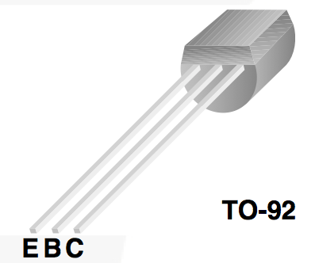
Figure 3 — Physical diagram showing Emitter, Base, and Collector pins for a TO-92 package. Note that the flat side of the package can be used to correctly orient the device. Both the 2N3904 and 2N3906 have the same pin mapping.

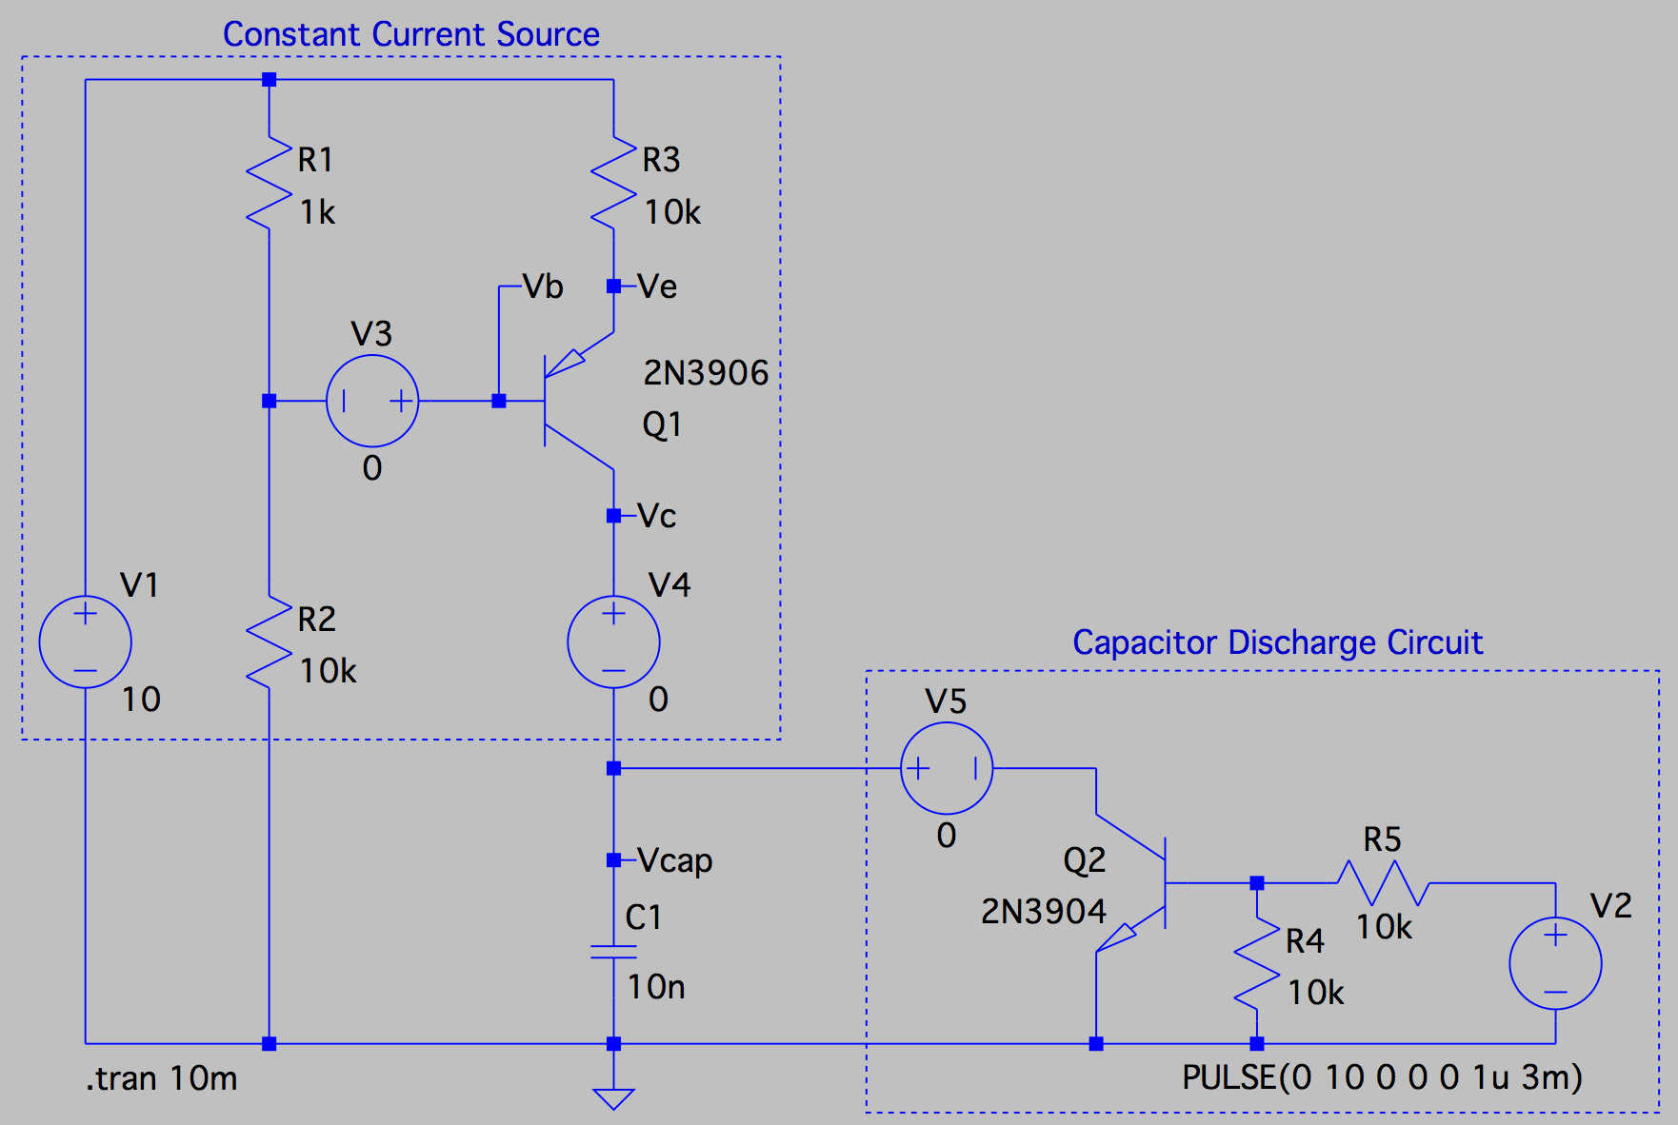
Task
Simulate and build the schematic shown in Figure 4 below.
Figure 4 — An LTSpice schematic. Notice the capacitor at the bottom. The voltage across this capacitor is the output of interest. Above the capacitor is a single-transistor constant current source. To the right is another transistor circuit that operates as a switch, periodically discharging the capacitor.

Source V1 is a 10V DC voltage source, representing the power supply at your workstation. Source V2 is a periodic pulse (10V amplitude, 1μs on-time, 3ms period) that controls the behavior of the discharge circuit. You can easily reproduce V2 with the function generator at your workstation. Sources V3, V4, and V5 have no physical meaning: they are simply an LTSpice technique for measuring the current through a line.

The device Q1 is your 2N3906 PNP transistor. To add this specific model to your schematic, open the LTSpice Component menu and select the generic Bipolar PNP Transistor (symbol “pnp”). After placing this symbol in your schematic, right-clicking on it should bring up a menu with a button to “Pick new transistor”. Click this button and sort the available devices by part number. There you’ll find the model for the 2N3906.

The device Q2 is your 2N3904 NPN transistor. To add this specific model to your schematic you can repeat the process above (make sure you instead select “npn” from the Component menu).

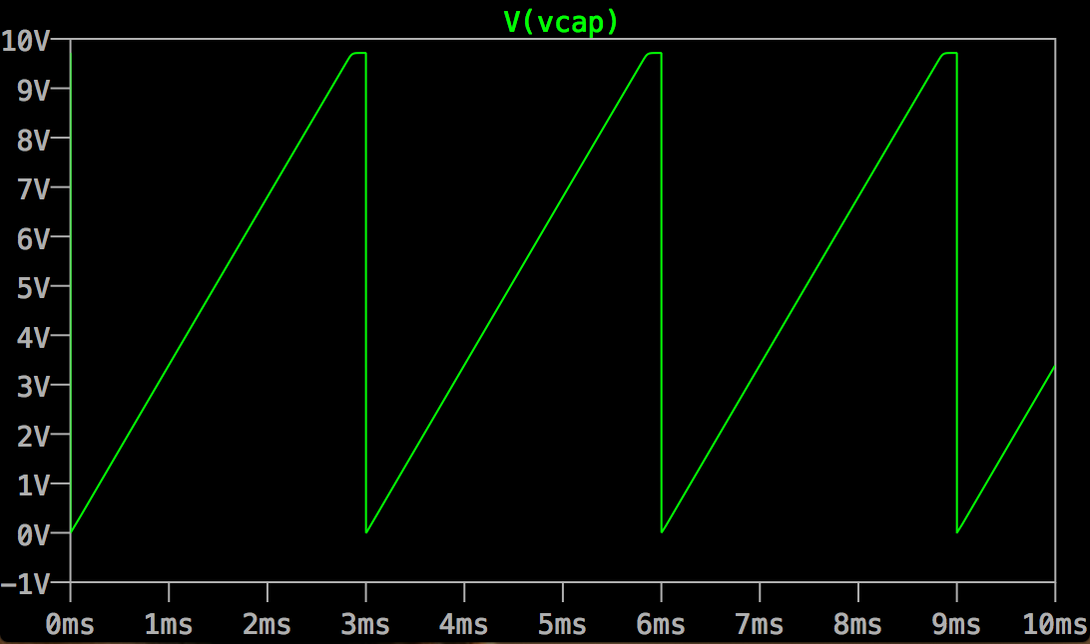
Running a transient simulation and measuring the voltage across the capacitor should result in an output similar to Figure 5 below. If you get something different, verify that you have your transistors oriented correctly.
Figure 5 — Capacitor voltage displaying ramp function behavior. Voltage is discharged periodically (every 3ms).

The next step is to prototype the circuit you just simulated on a breadboard. Your goal is to reproduce the measurement in Figure 5 on an oscilloscope.

After successfully reproducing the image above on your oscilloscope, use the OpenChoice software to take a screenshot. Make sure the screenshot contains today’s date as well as cursor measurements showing the ramp height and time (allowing you to calculate the slope).

Report
Write your report in whatever format you prefer, as long as it is well structured and easy to follow. Try to make it practical — could one of your peers who hasn’t taken this class learn from your work?

Be sure you address following:

- How you use the approximate DC model to calculate the current supplied by your single-transistor current source.
- How you calculate the slope of the capacitor voltage.
- How your calculations compare to simulations.
- How your simulations compare to physical measurements.
- What you did and what you learned.

